**Name:** Asad Haroon

**Reg#:** SP17-BCS-012

**Section:** C

**Task-1:**

**Switch to Switch Communication.**

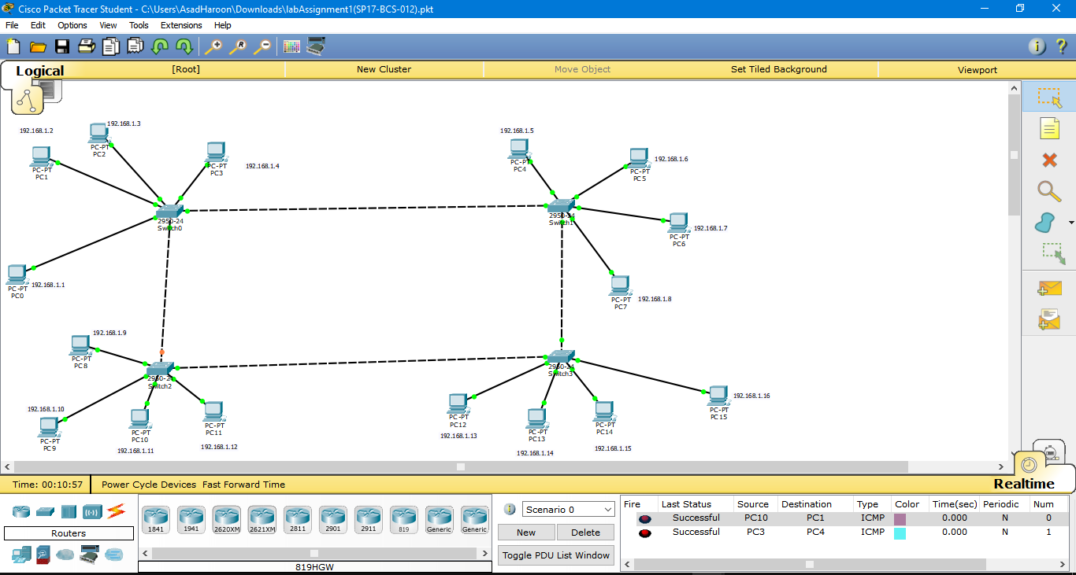

**Task-2:**

**Using One router communicate two networks.**

**CLI:**

**Router>enable**

**Router#config t**

**Enter configuration commands, one per line. End with CNTL/Z.**

**Router(config)#interface f0/0**

**Router(config-if)#ip address 192.168.1.1 255.255.255.0**

**Router(config-if)#no shutdown**

**Router(config-if)#**

**%LINK-5-CHANGED: Interface FastEthernet0/0, changed state to up**

**%LINEPROTO-5-UPDOWN: Line protocol on Interface FastEthernet0/0, changed state to up**

**Router(config-if)#interface f1/0**

**Router(config-if)#exit**

**Router(config)#interface f1/0**

**Router(config-if)#ip address 192.168.2.1 255.255.255.0**

**Router(config-if)#no shutdown**

**Router(config-if)#**

**%LINK-5-CHANGED: Interface FastEthernet1/0, changed state to up**

**%LINEPROTO-5-UPDOWN: Line protocol on Interface FastEthernet1/0, changed state to up**

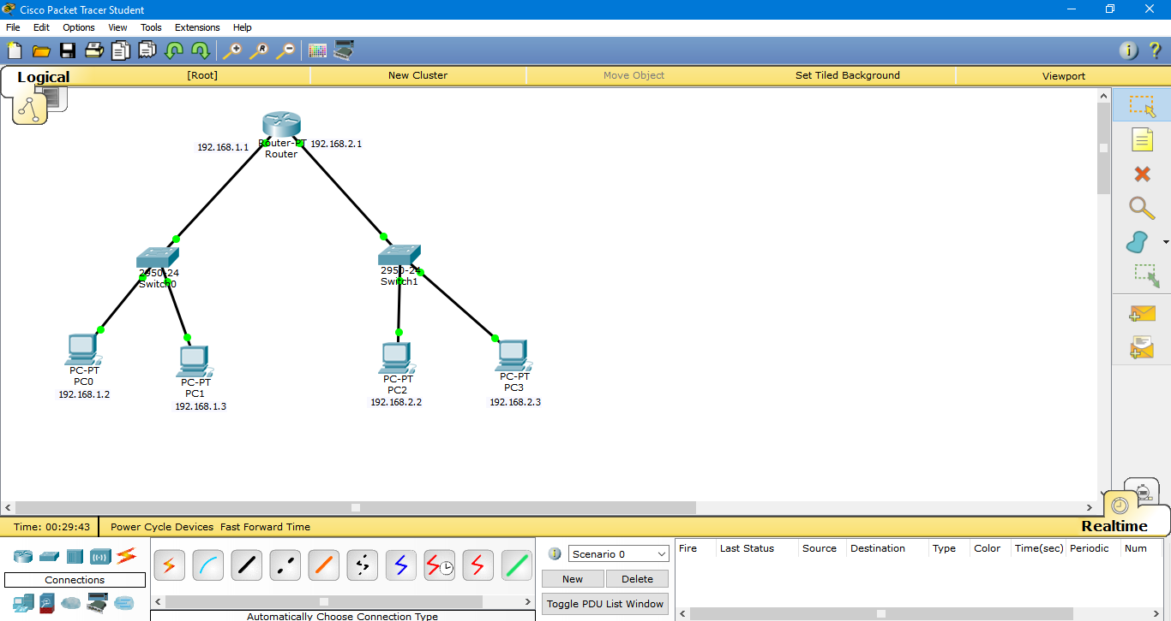

**Task-3: Two Routers Connection Using IP Route.**

**Router 2 CLI:**

Router>enable

Router#config t

Enter configuration commands, one per line. End with CNTL/Z.

Router(config)#interface f0/0

Router(config-if)#ip address 192.168.1.1 255.255.255.0

Router(config-if)#no shutdown

Router(config-if)#

%LINK-5-CHANGED: Interface FastEthernet0/0, changed state to up

%LINEPROTO-5-UPDOWN: Line protocol on Interface FastEthernet0/0, changed state to up

Router(config-if)#exit

Router(config)#interface se2/0

Router(config-if)#ip address 192.168.3.1 255.255.255.0

Router(config)#interface se2/0

Router(config-if)#ip route 192.168.2.0 255.255.255.0 192.168.3.2

Router(config)#interface se2/0

Router(config-if)#no shutdown

Router(config-if)#

%LINK-5-CHANGED: Interface Serial2/0, changed state to up

%LINEPROTO-5-UPDOWN: Line protocol on Interface Serial2/0, changed state to up

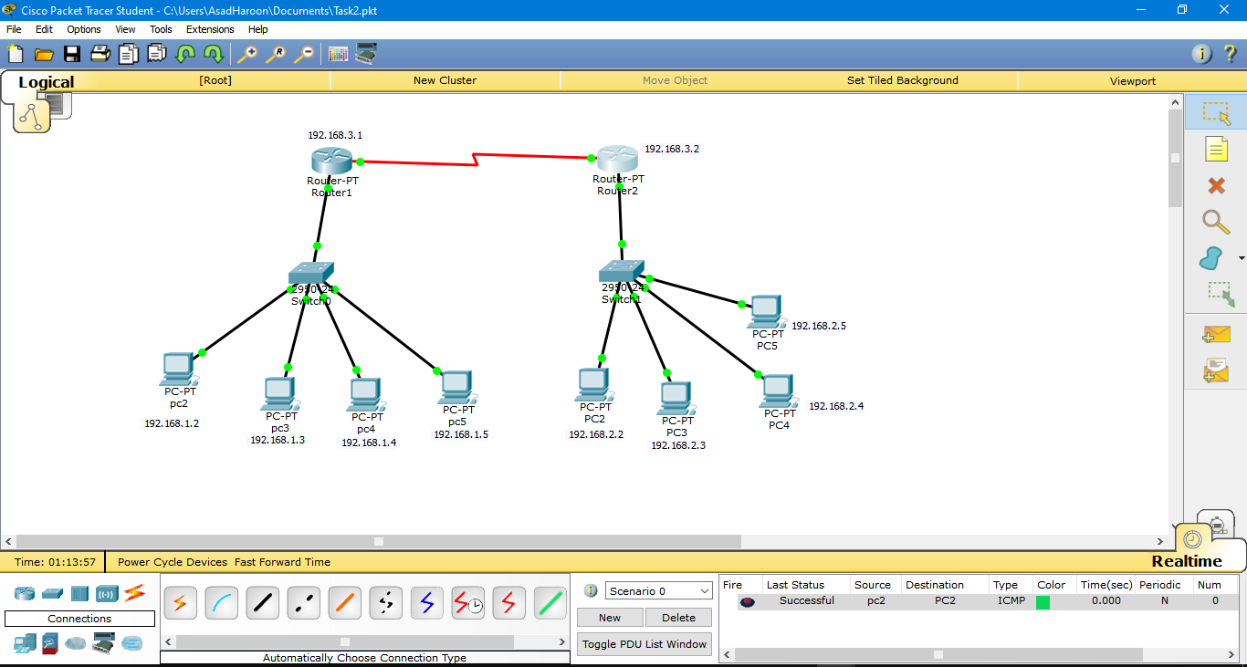

**Router1 CLI:**

Router>enable

Router#config t

Enter configuration commands, one per line. End with CNTL/Z.

Router(config)#interface f0/0

Router(config-if)#ip address 192.168.2.1 255.255.255.0

Router(config-if)#no shutdown

Router(config-if)#

%LINK-5-CHANGED: Interface FastEthernet0/0, changed state to up

%LINEPROTO-5-UPDOWN: Line protocol on Interface FastEthernet0/0, changed state to up

Router(config-if)#interface se2/0

Router(config-if)#ip address 192.168.3.2 255.255.255.0

Router(config-if)#no shutdown

%LINK-5-CHANGED: Interface Serial2/0, changed state to down

Router(config-if)#no shutdown

Router(config-if)#

%LINK-5-CHANGED: Interface Serial2/0, changed state to up

Router(config-if)#ip

%LINEPROTO-5-UPDOWN: Line protocol on Interface Serial2/0, changed state to u

Router(config-if)#ip route 192.168.1.0 255.255.255.0 192.168.3.1

Router(config)#interface se2/0

Router(config-if)#no shutdown

**Task-4: Two Router Connection using RIP**

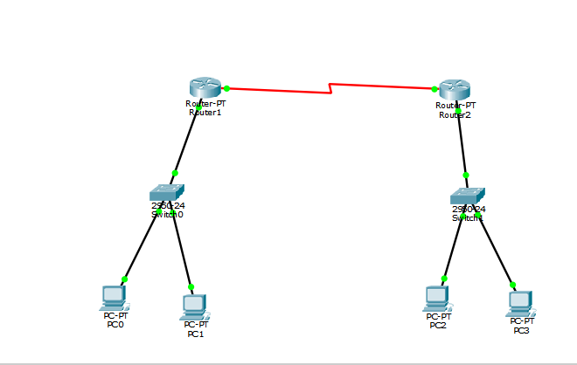

**CLI:**

**Router1 RIP:**

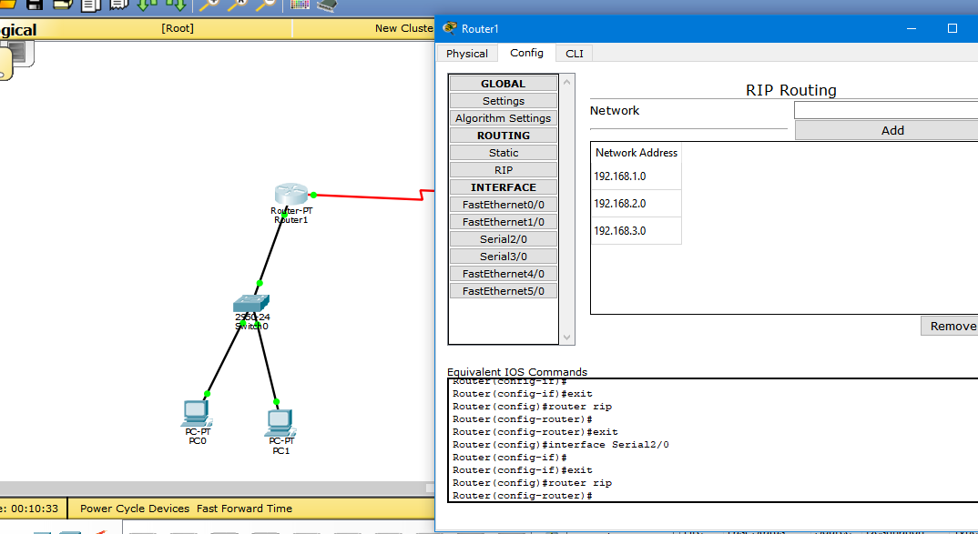

**Router2 RIP:**

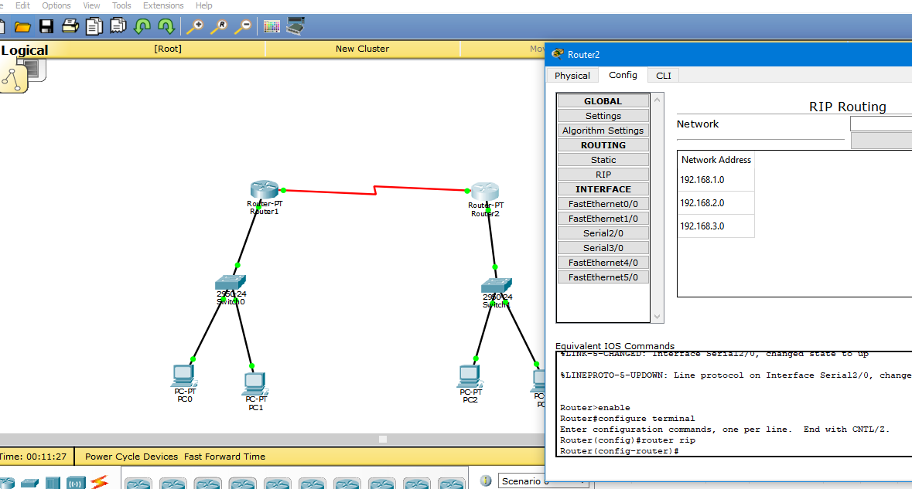

**Task-5: 3 routers Connection Using RIP Router**

R**outer0 CLI:**

Router>enable

Router#configure terminal

Enter configuration commands, one per line. End with CNTL/Z.

Router(config)#

Router(config)#router rip

Router(config-router)#

Router(config-router)#exit

Router(config)#router rip

Router(config-router)#

Router(config-router)#exit

Router(config)#router rip

Router(config-router)#no network 192.168.6.0

Router(config-router)#

Router(config-router)#exit

Router(config)#router rip

Router(config-router)#network 192.168.6.0

Router(config-router)#

Router(config-router)#exit

Router(config)#router rip

Router(config-router)#

Router(config-router)#exit

Router(config)#interface Serial2/0

Router(config-if)#clock rate 128000

This command applies only to DCE interfaces

Router(config-if)#

Router(config-if)#exit

Router(config)#router rip

Router(config-router)#

Router(config-router)#exit

Router(config)#interface Serial2/0

Router(config-if)#clock rate 148000

This command applies only to DCE interfaces

Router(config-if)#

Router(config-if)#exit

Router(config)#interface Serial2/0

Router(config-if)#

Router(config-if)#exit

Router(config)#interface Serial2/0

Router(config-if)#ip address 192.168.3.1 255.255.255.0

Router(config-if)#

Router(config-if)#exit

Router(config)#router rip

Router(config-router)#no network 192.168.6.0

Router(config-router)#

**Router3 CLI:**

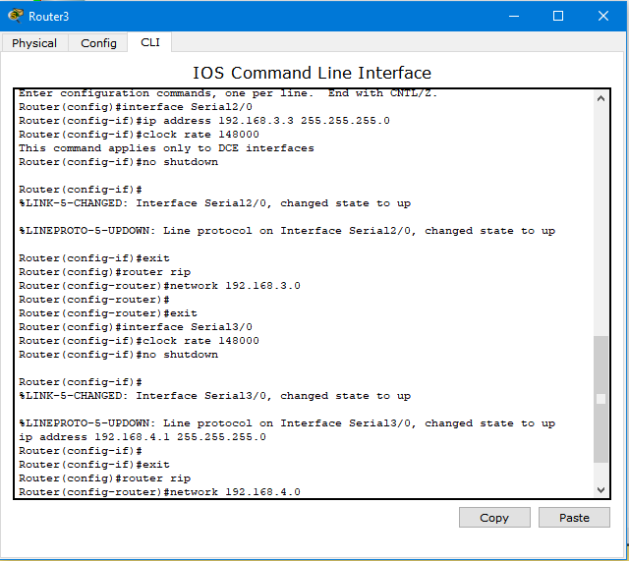

**Router2 CLI:**

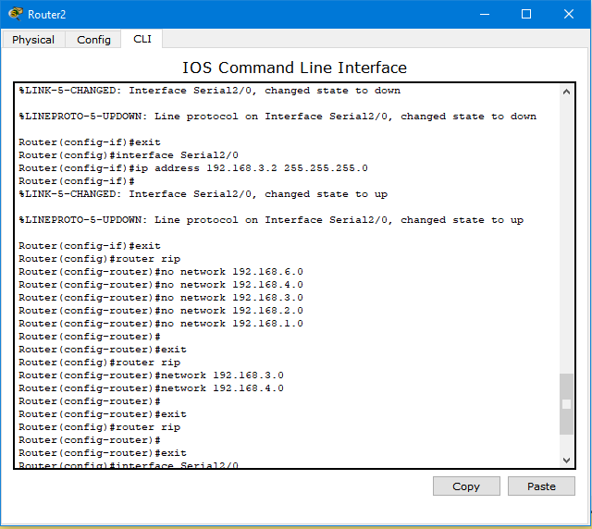

**Network:**

